Looking for the Last Will and Testament of

Edward Barry Farmer

Original will was executed on Dec 12, 2002 and held by former lawyer, Paul Caroline, who practiced at 16775 Yonge St, Newmarket, ON, L3Y 8J4.

If you are in possession of, or know the whereabouts of Mr. Caroline’s files, please contact:

Victoria Thompson
416-899-7638
victoria1794@hotmail.com

A $5000 reward is offered for locating this original signed will.

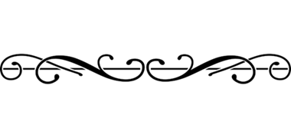
Looking for the Last Will and Testament of

Douglas Edwond Burns

Date of death: September 11, 2019
Date of birth: April 7, 1968

Resided at 6147 Main St., Stouffville ON

Please contact:
Liz Ham
Barrister & Solicitor
T: 613-722-9300
E: lizham.law@gmail.com
Looking for the Last Will and Testament of

Frederick Harold Holton

Date of death: February 9, 2019

Original of will held by former lawyer, Gordon Watkin (“Watkin”), who practiced at 9350 Yonge Street, Suite 200, Richmond Hill, Ontario, L4C 5G2, but was disbarred in 2011. If you are in possession of, or know the whereabouts of Mr. Watkin’s files, please contact:

Gaetano Barrila
Barrister, Solicitor, Notary Public
Barrila Law
37 Jacob Keffer Parkway, Suite 301, Vaughan, ON L4K 5N8 (Head Office) T: (905) 326-2767
F: 1 (888) 326-0172
E: gaetano@barrilalaw.com
W: www.barrilalaw.com
Looking for the Last Will and Testament of

Florence Ifeyinwa Aduwari

Date of birth: June 13, 1968
Date of death: January 8, 2019
Place of death: Mississauga, Ontario

Please contact

Krum A. Dochev, Barrister & Solicitor
Associate Lawyer, Epstein & Associates
71 Main St. S, Newmarket ON L3Y 3Y5
T: 905.898.2266 ext. 220
F: 905.898.2216
E: KDochev@epsteinlaw.ca
www.epsteinlaw.ca
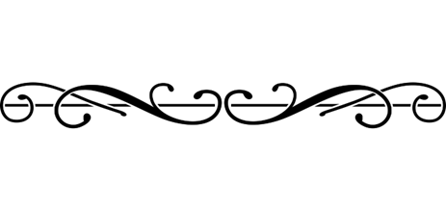
Looking for the Last Will and Testament of

Melvin Mark Whiteman

of the Aurora/Stouville area, who passed away on or about June 5, 2019.

Please contact Jen Brown at Menlove Law Professional Corporation by phone: (613) 476-2116 or Fax: (613) 476-8143.

Jennifer Brown, Lawyer
Menlove Law Professional Corp.
316 Main Street, Picton, ON K0K 2T0
Tel: (613) 476-2116
Fax: (613) 476-8143

Anyone having knowledge of a Last Will and Testament of

MATTHIAS ROBERT ALBERT TERFLOTH (DOD DECEMBER 17, 2019)

Please contact
Shirtliff-Hinds Law Office
205 Main Street South, Newmarket, ON L3Y 3Y9
Phone: (289) 319-0606 ext. 117
Fax: (289) 319-0607
www.shirtlifflaw.ca
Looking for information regarding the management of the estate of:

BARBARA FRANCIS COX of Keswick, formerly of Gravenhurst

Date of Death April 12, 2019

Please contact

Heather G. Gillies
Gillies Law
16 Industrial Parkway South
Aurora, Ontario L4G 0R4
Tel: (365) 500-2007
Fax: (365) 500-2008
Looking for the Last Will and Testament of

CHERYL ANNE FAWCETT

Please contact Amanda M. Swarbreck at Feehely Gastaldi in Alliston.

Thank you very much.

Feehely Gastaldi
2 Victoria Street East, P.O. Box 339
Alliston, ON L9R 1V6
amanda@fglawyers.ca
Tel: 705-435-4386 or 1-800-665-2945 ext. 34
Fax: 705-435-9256
www.feehelygastaldi.com

